|  |  |
| --- | --- |
| Activity | Data Type |
| Number of beatings from Wife | Discrete |
| Results of rolling a dice | Discrete |
| Weight of a person | Continuous |
| Weight of Gold | Continuous |
| Distance between two places | Continuous |
| Length of a leaf | Continuous |
| Dog's weight | Continuous |
| Blue Color | Discrete |
| Number of kids | Discrete |
| Number of tickets in Indian railways | Discrete |
| Number of times married | Discrete |
| Gender (Male or Female) | Discrete |

Q1) Identify the Data type for the Following:

Q2) Identify the Data types, which were among the following

Nominal, Ordinal, Interval, Ratio.

|  |  |
| --- | --- |
| Data | Data Type |
| Gender | Nominal |
| High School Class Ranking | Ordinal |
| Celsius Temperature | Interval |
| Weight | Ratio |
| Hair Color | Nominal |
| Socioeconomic Status | Ordinal |
| Fahrenheit Temperature | Interval |
| Height | Ratio |
| Type of living accommodation | Ordinal |
| Level of Agreement | Ordinal |
| IQ(Intelligence Scale) | Ratio |
| Sales Figures | Interval |
| Blood Group | Nominal |
| Time Of Day | Ratio |
| Time on a Clock with Hands | Ratio |
| Number of Children | Ordinal |
| Religious Preference | Nominal |
| Barometer Pressure | Ratio |
| SAT Scores | Ratio |
| Years of Education | Interval |

Q3) Three Coins are tossed, find the probability that two heads and one tail are obtained?

Ans- When three coins are tossed the total no of possible combinations are 8

Combinations are – HHH,HHT,HTH,THH,TTH,THT,HTT,TTT

The no of combinations which have two heads and one tail are

HHT,HTH,TTH

Probability of two heads and one tail is =3/8=0.375

Q4) Two Dice are rolled, find the probability that sum is

1. Equal to 1
2. Less than or equal to 4
3. Sum is divisible by 2 and 3

**Ans:-** a) Probability that sum is equal to 1

P(1)=0

b)When two dice are rolled then the probability of getting number 4 is (1,1),(1,2),(1,3),(2,1),(2,2) so

The no of outcomes =6

Total no of possibilities =36

Probability=6/36=1/6

Thus,1/12 is the probability of rolling two dice and getting sum of 4

c)Probabilities of sum is divisible by 2 and 3

total no of possible outcomes =36

favourable outcomes= (1,5),(3,3),(2,4),(4,2),(5,1),(6,6) = 6

Probability = No of favorable outcome/No of possible outcomes= 6/36 =1/6

Q5) A bag contains 2 red, 3 green and 2 blue balls. Two balls are drawn at random. What is the probability that none of the balls drawn is blue?

Ans :- Total no of balls-7

Let S be the sample space

Then n(S) =Number of ways of drawing 2 balls out of 7

n(S) =7c2

n(S) = (7X6)/(2X1)

n(S) = 21

Let E = Event of 2 balls ,none of which is blue therefore

n(E)= Number of ways of drawing 2 balls out of (2+3) balls

n(E) = 5c2

n(E)= (5x4)/(2x1)

n(E) = 10

therefore P(E)= n(E) / n(S)

= 10/21

=0.4761

Q6) Calculate the Expected number of candies for a randomly selected child

Below are the probabilities of count of candies for children (ignoring the nature of the child-Generalized view)

|  |  |  |
| --- | --- | --- |
| CHILD | Candies count | Probability |
| A | 1 | 0.015 |
| B | 4 | 0.20 |
| C | 3 | 0.65 |
| D | 5 | 0.005 |
| E | 6 | 0.01 |
| F | 2 | 0.120 |

Child A – probability of having 1 candy = 0.015.

Child B – probability of having 4 candies = 0.20

Answer:- The expected number of candies for a randomly selected child

= (1*0.015) +(4*0.20) +(3*0.65) +(5*0.005) +(6*0.01) +(2*0.120)

= 0.015+0.8+1.95+0.025+0.06+0.24

= 3.09

Q7) Calculate Mean, Median, Mode, Variance, Standard Deviation, Range & comment about the values / draw inferences, for the given dataset

* For Points,Score,Weigh>

Find Mean, Median, Mode, Variance, Standard Deviation, and Range and also Comment about the values/ Draw some inferences.

**Use Q7.csv file**

**Ans:-**

|  |  |  |  |
| --- | --- | --- | --- |
|  | **Points** | **Score** | **Weight** |
| **Mean** | 3.596563 | 3.21725 | 17.84875 |
| **Median** | 3.695 | 3.325 | 17.71 |
| **Mode** | 3.92 | 3.44 | 17.02 |
| **Variance** | 0.28588 | 0.95738 | 3.19317 |
| **Standard Deviation** | 0.53468 | 0.97846 | 1.7869432 |
| **Range** | **2.17** | **3.911** | **8.4** |

Q8) Calculate Expected Value for the problem below

1. The weights (X) of patients at a clinic (in pounds), are

108, 110, 123, 134, 135, 145, 167, 187, 199

Assume one of the patients is chosen at random. What is the Expected Value of the Weight of that patient?

Answer: -

|  |  |  |  |  |  |  |  |  |  |
| --- | --- | --- | --- | --- | --- | --- | --- | --- | --- |
| E(x) | 108 | 110 | 123 | 134 | 135 | 145 | 167 | 187 | 199 |
| P(x) | 1/9 | 1/9 | 1/9 | 1/9 | 1/9 | 1/9 | 1/9 | 1/9 | 1/9 |

Probability = (1/9*108) +(1/9*110) +(1/9*123) +(1/9*134) +(1/9*135)

+(1/9*145) +(1/9*167) +(1/9*187) +(1/9*199)

= 145.33 pounds

**Q9) Calculate Skewness, Kurtosis & draw inferences on the following data**

**Cars speed and distance**

**Use Q9_a.csv**

**Ans :-**

|  |  |  |
| --- | --- | --- |
|  | **Speed** | **Dist** |
| **Skewness** | **-0.117509861** | **0.80689496** |
| **Kurtosis** | **-0.50899442** | **0.405052582** |
| **Mean** | **15.4** | **42.98** |
| **Median** | **15** | **42.98** |
| **Mode** | **20** | **26** |

**SP and Weight(WT) Use Q9_b.csv**

**Ans:-**

|  |  |  |
| --- | --- | --- |
|  | **SP** | **WT** |
| **Skewness** | **1.611450196** | **-0.614753326** |
| **Kurtosis** | **2.977328944** | **0.950291491** |
| **Mean** | **121.5402722** | **32.41257691** |
| **Median** | **118.2086984** | **32.73451818** |
| **Mode** | **118.28889958** |  |

**Q10) Draw inferences about the following boxplot & histogram**

ANASA



Answer: This Histogram shows Positive skewed distribution, because Mean>Median>mode.



Answer :- In this boxplot many(higher) outliers available of dataset.

**Q11)** Suppose we want to estimate the average weight of an adult male in Mexico. We draw a random sample of 2,000 men from a population of 3,000,000 men and weigh them. We find that the average person in our sample weighs 200 pounds, and the standard deviation of the sample is 30 pounds. Calculate 94%,98%,96% confidence interval?

Answer:-

Confidence Interval = x̄ ± zα/2(σ/√n)

CI = Confidance Interval

X= Sample mean=200

Z = confidence level value

S= sample standard deviation = 30

N = sample size = 2000

|  |  |  |  |
| --- | --- | --- | --- |
|  | **94%** | **96%** | **98%** |
| **CI** | 134.89, 265.102 | 130.209, 269.790 | 122.725, 277.274 |

**Q12)** Below are the scores obtained by a student in tests

**34,36,36,38,38,39,39,40,40,41,41,41,41,42,42,45,49,56**

1. Find mean, median, variance, standard deviation.
2. What can we say about the student marks?

Answer 1

|  |  |  |  |  |
| --- | --- | --- | --- | --- |
|  | Mean | Median | Variance | Standard Deviation |
| 34,36,36,38,38,  39,39,40,40,41,  41,41,41,42,42,  45,49,56 | 41 | 40.5 | 25.52941 | 5.052664 |

Answer -2

Students marks are multimodal.

Q13) What is the nature of skewness when mean, median of data are equal?

Answer:- Symmetric

Q14) What is the nature of skewness when mean > median ?

Answer:- Positive Skew

Q15) What is the nature of skewness when median > mean?

Answer:- Negative Skew

Q16) What does positive kurtosis value indicates for a data ?

Answer:- Distribution is peaked and possesses thick tails.

Q17) What does negative kurtosis value indicates for a data?

Answer:- distribution is flat and has thin tails

Q18) Answer the below questions using the below boxplot visualization.



What can we say about the distribution of the data?

Answer:- Non-Symmetric distribution (median > mean)

What is nature of skewness of the data?

Answer:- Negative Skewed

What will be the IQR of the data (approximately)?

Answer:-

Q1 = 10, Q3 = 18

Q3-Q1 = 18-10 = 8

Q19) Comment on the below Boxplot visualizations?



Draw an Inference from the distribution of data for Boxplot 1 with respect Boxplot 2.

Answer:

* In first boxplot the median is closer to Q1 so that this positively skewed i.e., Mean & median is greater than mode.
* In second boxplot median is in the middle where mean = median so there is symmetric distribution.

Q 20) Calculate probability from the given dataset for the below cases

Data _set: Cars.csv

Calculate the probability of MPG of Cars for the below cases.

MPG <- Cars$MPG

* 1. P(MPG>38)
  2. P(MPG<40)
  3. P (20<MPG<50)

Answer:

1. P(MPG>38) = 0.34750288929863415
2. P(MPG<40) = 0.7294349739243934
3. P(20<MPG<50) = 0.8988805681995043

Q 21) Check whether the data follows normal distribution

1. Check whether the MPG of Cars follows Normal Distribution

Dataset: Cars.csv

Answer: as per the calculation data has not Normal Distribution.

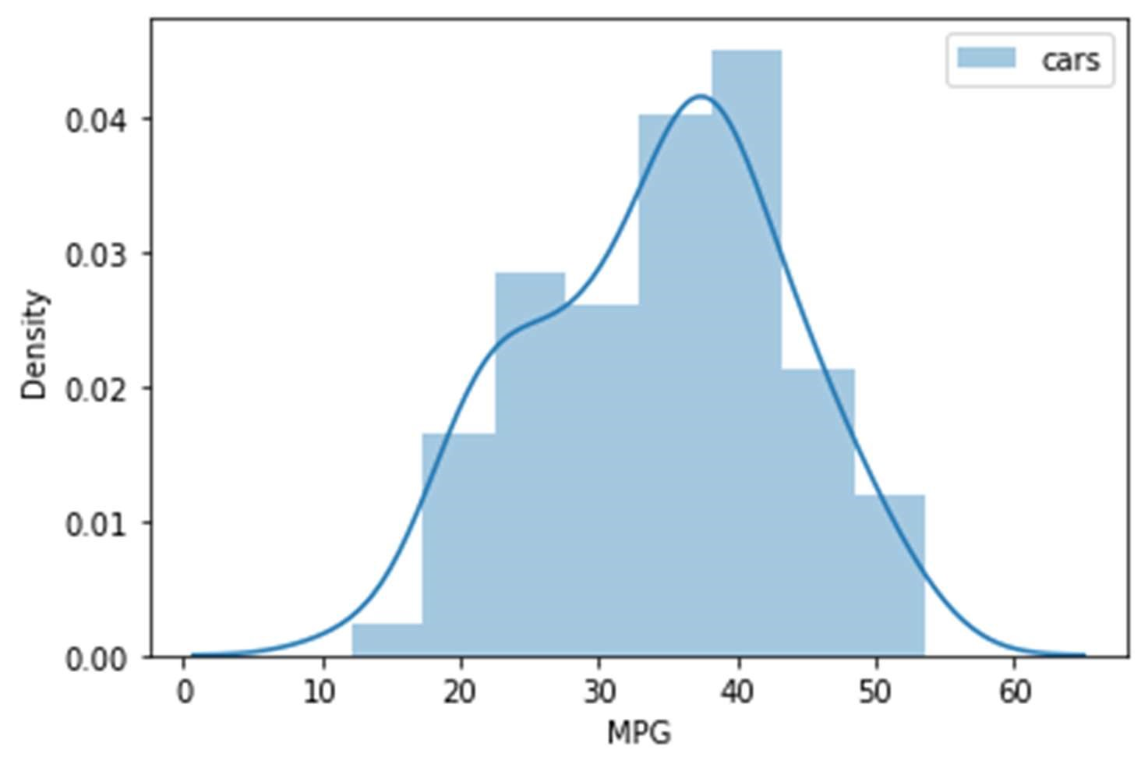

1. Check Whether the Adipose Tissue (AT) and Waist Circumference(Waist) from wc-at data set follows Normal Distribution

Dataset: wc-at.csv

Answer: As per the calculation data has not Normal Distribution.

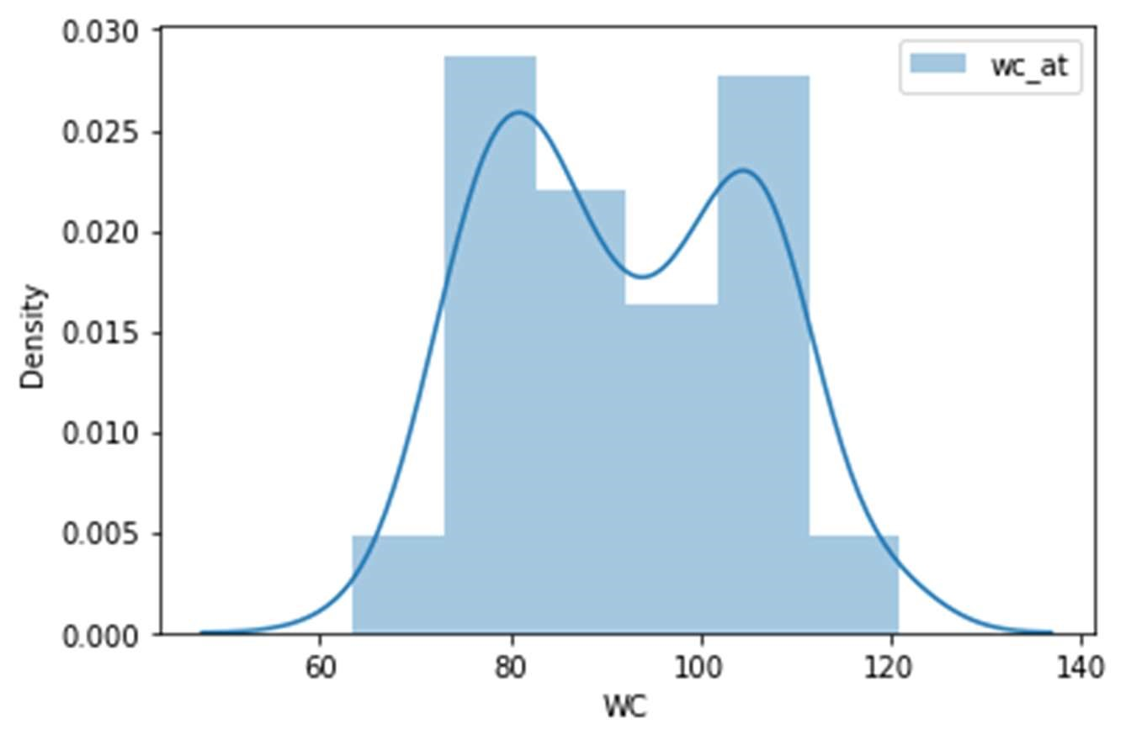

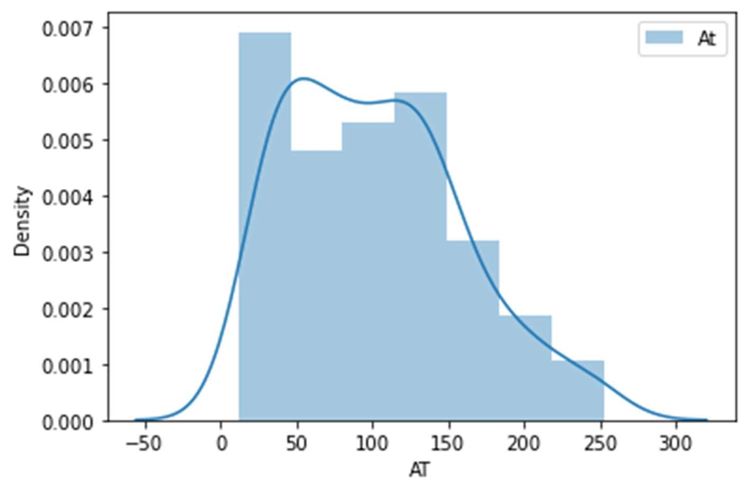

Q 22) Calculate the Z scores of 90% confidence interval,94% confidence interval, 60% confidence interval

Answer:-

|  |  |
| --- | --- |
| percentage | Confidence Interval |
| 90 | 1.959963984540054 |
| 94 | 1.8807936081512509 |
| 60 | 0.8416212335729143 |

Q 23) Calculate the t scores of 95% confidence interval, 96% confidence interval, 99% confidence interval for sample size of 25

Answer:

|  |  |
| --- | --- |
| percentage | Confidence Interval |
| 95 | 2.0638985616280205 |
| 96 | 1.8807936081512509 |
| 99 | 0.8416212335729143 |

Q 24**)** A Government company claims that an average light bulb lasts 270 days. A researcher randomly selects 18 bulbs for testing. The sampled bulbs last an average of 260 days, with a standard deviation of 90 days. If the CEO's claim were true, what is the probability that 18 randomly selected bulbs would have an average life of no more than 260 days

Hint:

rcode 🡪 pt(tscore,df)

df 🡪 degrees of freedom

Answer:-

t - statistics for the data is given as follows:



x = mean of the sample of bulbs =  260

μ = population mean = 270

s = standard deviation of the sample = 90

n = number of items in the sample = 18









t = - 0.471

For probability calculations, the number of degrees of freedom is n - 1, so here you need the t-distribution with 17 degrees of freedom.

The probability that **t < - 0.471 with 17 degrees of freedom** assuming the population mean is true, the t-value is less than the t-value obtained With 17 degrees of freedom and a t score of - 0.471, the probability of the bulbs lasting less than 260 days on average of **0.3218** assuming the mean life of the bulbs is 300 days.

**So probability = 0.3218**